**EXPERIMENT : 7**

CARD PROCESSING SYSTEM

USE CASE DIAGRAM

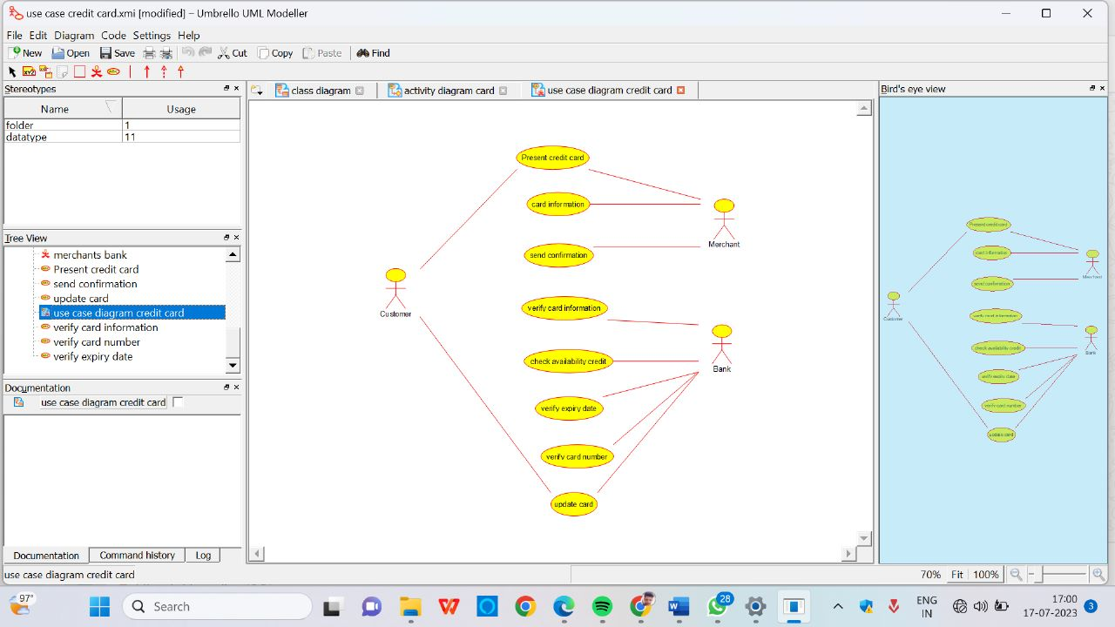

ACTIVITY DIAGRAM

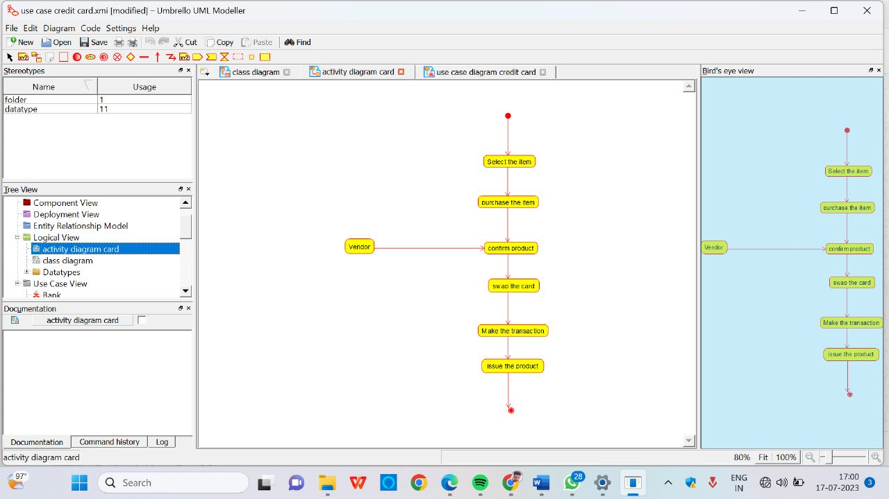

CLASS DIAGRAM

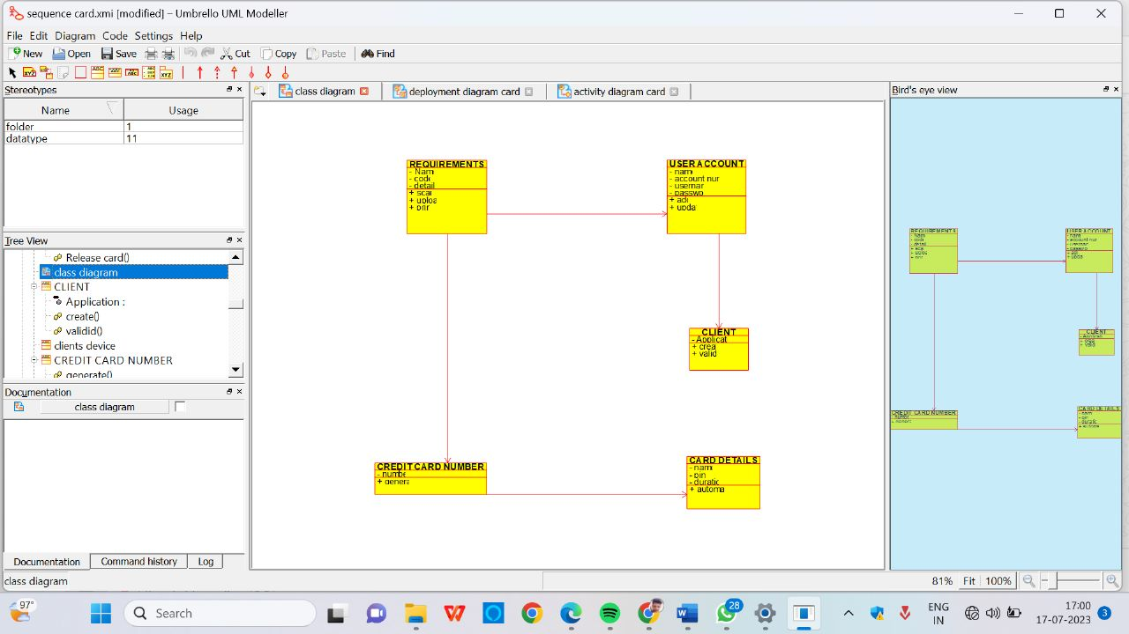

SEQUENCE DIAGRAM

